ASSIGNMENT – 03
- Log in to your home Wi-Fi router's admin panel using its default IP address (usually 192.168.0.1 or 192.168.1.1) and take a screenshot of the login page.<br><br><em><strong>Hint:</strong> If you don't know your router's IP, open Command Prompt and run 'ipconfig' — look for 'Default Gateway'.</em>

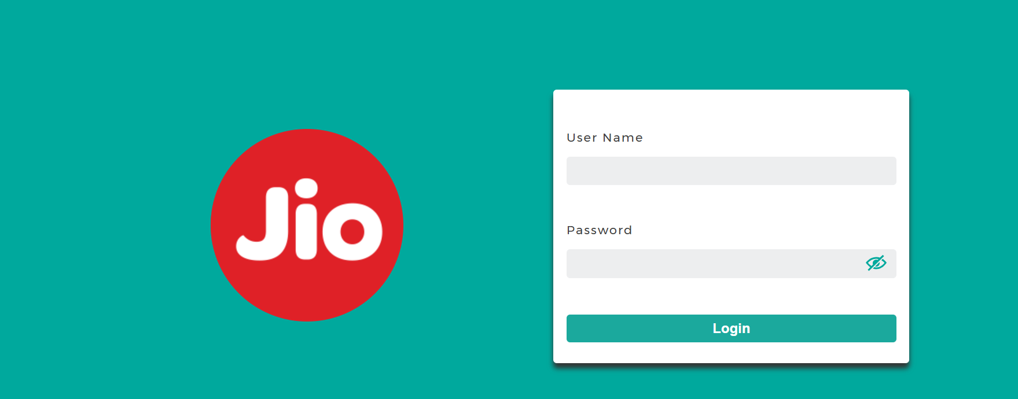

- Find and note down the current IP address, subnet mask, and default gateway assigned to your laptop or mobile device when connected to your Wi-Fi network.

C:\Users\visha>ipconfig

Windows IP Configuration

Ethernet adapter Ethernet:

Media State . . . . . . . . . . . : Media disconnected
Connection-specific DNS Suffix . :

Wireless LAN adapter Local Area Connection* 1:

Media State . . . . . . . . . . . : Media disconnected
Connection-specific DNS Suffix . :

Wireless LAN adapter Local Area Connection* 10:

Media State . . . . . . . . . . . : Media disconnected
Connection-specific DNS Suffix . :

Wireless LAN adapter WiFi:

Connection-specific DNS Suffix . : mshome.net
IPv4 Address. . . . . . . . . . . : 192.168.29.139
Subnet Mask . . . . . . . . . . . : 255.255.255.0
Default Gateway . . . . . . . . . : 192.168.29.1

Ethernet adapter Bluetooth Network Connection:

Media State . . . . . . . . . . . : Media disconnected
Connection-specific DNS Suffix . :

- Change your device's IP address from 'Obtain IP automatically' (DHCP) to a static IP in the same range as your router (for example, set it to 192.168.1.50 if your router is 192.168.1.1), and test if you still have internet access.<br><br><em><strong>Constraint:</strong> Remember to revert to automatic/DHCP after testing to avoid network issues.</em>

Yes. Based on your actual Wi-Fi details, here are all the steps line by line.
Step 1 — Open Settings
- Press Windows + I.
- Click Network & Internet.
- Click Wi-Fi.
- Click your connected Wi-Fi network.
Step 2 — Open IP Settings
- Find IP assignment.
- Click Edit.
- Select Manual.
- Turn IPv4 ON.
Step 3 — Enter These Values
Enter exactly:
- IP address: 192.168.29.50
- Subnet prefix length: 24
- Gateway: 192.168.29.1
- Preferred DNS: 8.8.8.8
- Alternate DNS: 8.8.4.4
- Click Save.
Step 4 — Check the IP Address
- Press Windows + R.
- Type cmd.
- Press Enter.
- Type:
ipconfig
- Press Enter.
- Under Wireless LAN adapter WiFi, check that you have:
IPv4 Address : 192.168.29.50
Subnet Mask : 255.255.255.0
Default Gateway : 192.168.29.1
Step 5 — Test Router Connection
- In Command Prompt, type:
ping 192.168.29.1
- Press Enter.
- If you see Reply from 192.168.29.1, your connection to the router is working. ✅
Step 6 — Test Internet
- Type:
ping google.com
- Press Enter.
- If you see Reply from..., your Internet is working with the static IP. ✅
- Open your browser and check whether websites load.
Step 7 — IMPORTANT: Change Back to DHCP
After testing:
- Go to Settings → Network & Internet → Wi-Fi.
- Open your connected Wi-Fi network.
- Find IP assignment.
- Click Edit.
- Change Manual to Automatic (DHCP).
- Click Save.
- Open Command Prompt again.
- Type:
ipconfig
- Your computer should receive an IP automatically again.
Final Result
Before:
192.168.29.139 → DHCP
During testing:
192.168.29.50 → Static IP
After testing:
Automatic (DHCP) → Restored ✅
- In your router's admin panel, locate the section where you can view or change the DHCP range. Write down the current range, and explain in 2-3 lines what would happen if two devices are assigned the same IP address in this range.

Steps
- Open a web browser.
- Enter 192.168.29.1 in the address bar.
- Log in to your router's admin panel.
- Look for LAN Settings, DHCP Server, or Network Settings.
- Find DHCP Range / DHCP Address Pool.
- Write down the Start IP and End IP shown there.

